ECE356 Project - Social Network Entity-Relationship Model

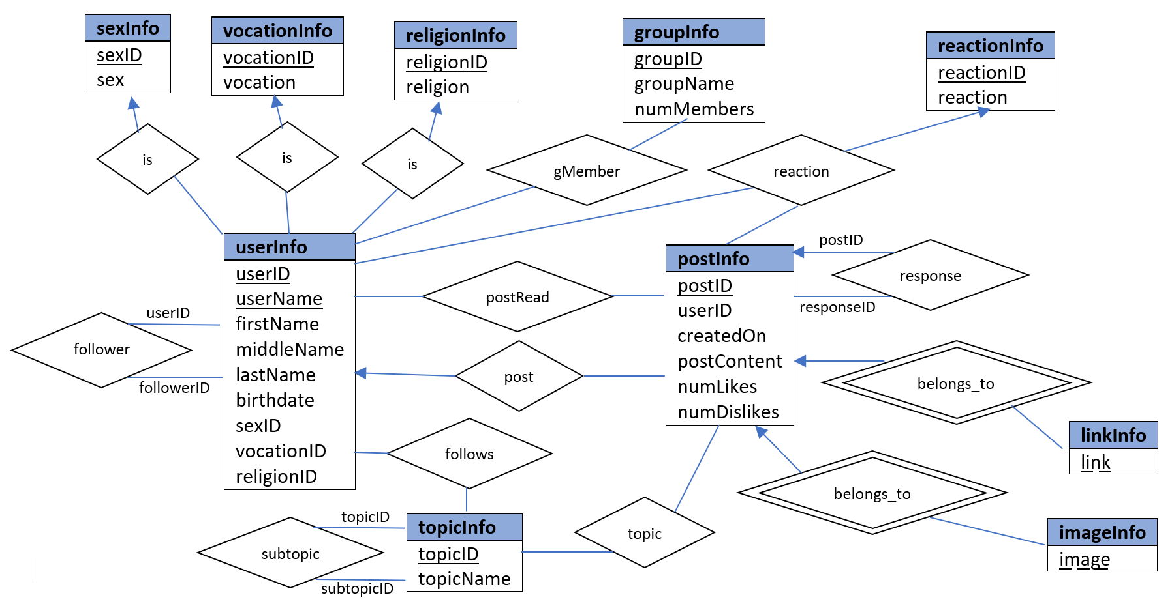This file is the deliverable for the first item of the project.

The above diagram is the entity-relationship model for the simple social network. All notational conventions are as per the posted lecture notes (part06 – ER Modeling).

The description of relationships are as follows:

**userInfo** and **follower**

* This is a **many-to-many** relationship, as a **user** can **follow** multiple **other users** and vice versa.

**userInfo**, **sexInfo**, **vocationInfo**, and **religionInfo**

* These are **one-to-many** relationships, as a **user** can only have **one** **sex**, **vocation**, and **religion** respectively.

**userInfo**, **groupInfo**, and **gMember**

* Entities **UserInfo** and **GroupInfo** are connected by relationship set **gMember**. This is a **many-to-many** relationship as a **user** can be a **member** in multiple **groups** and a **group** can have multiple **members**.

**userInfo**, **postInfo**, **reactionInfo**, and **reaction**

* Entities **userInfo**, **postInfo**, and **reactionInfo** are connected by relationship set **reaction**. This is a **ternary** relationship as a **user** can **react** to a **post** (like or dislike).

**userInfo**, **postInfo**, **postRead**, and **post**

* Entities **userInfo** and **postInfo** are connected by relationship set **postRead**. This is a **many-to-many** relationship as a **user** can **read** multiple **posts** and a **post** can be **read** by multiple **users**.
* Entities **userInfo** and **postInfo** are also connected by relationship set **post**. This is a **one-to-many** relationship since there is at most **one user** per **post**, but a **user** can have multiple **posts**.

**postInfo** and **response**

* This is a **one-to-many** relationship as a **post** can have multiple **responses** but a **response** only belongs to **one post**.

**postInfo**, **linkInfo**, and **imageInfo**

* These are **one-to-many** relationships as a there is at most **one post** per **image** or **link**, but a **post** can have multiple **images** or **links**.

**userInfo**, **topicInfo**, and **follows**

* Entities **userInfo** and **topicInfo** are connected by relationship set **follows**. This is a **many-to-many** relationship as a **user** can **follow** multiple **topics** and a **topic** can be **followed** by multiple **users**.

**topicInfo** and **subtopic**

* This is a **many-to-many** relationship as a **topic** can have multiple **subtopics** and a **subtopic** can belong in multiple **topics**.

**postInfo**, **topicInfo**, and **topic**

* Entities **postInfo** and **topicInfo** are connected by relationship set **topic**. This is **a many-to-many** relationship as a **post** can have multiple **topics** and a **topic** can belong in multiple **posts**.